MAIN PROJECT REPORT
TITLE: MERCEDES BENZ CLASA-E

Data Source: Company Dataset
Year: Nov 2025
Cleaned Dataset and Power BI Report

Folder Link:
https://drive.google.com/drive/folders/1_0HiwMjCF6jgafGyWq-Tb6nhhhWQSJ-g?usp=sharing

Github Link:
https://github.com/RubanMc2003/DA-FINAL-PROJECT

Problem Statement:

The price of a used Mercedes-Benz E-Class car depends on many factors like year, mileage, fuel type, and engine power.

Buyers and sellers often find it difficult to understand how these factors affect the car’s value.

Analyzing this dataset helps estimate fair prices and supports better buying and selling decisions.

POWER BI:
DASHBOARD REPORT:
The exclusive dashboard report was developed using page-level filters along with various visualizations, including line graphs, pie charts, donut charts, area charts, stacked area charts, KPIs, and maps. By utilizing slicers, multiple views and detailed analyses of the dataset can be accessed and explored effectively.

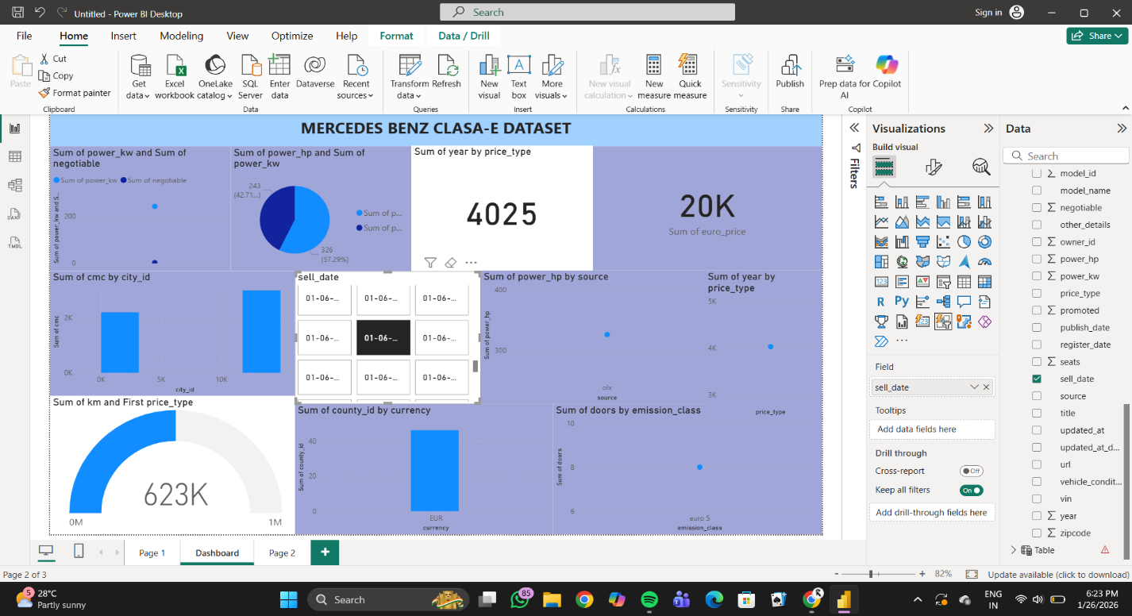

1.DESCRIPTIVE:
- The dataset contains 6,448 records of Mercedes-Benz E-Class cars, collected from online car listings. Each record represents one car advertisement.
- It includes information about the car details such as brand, model, year, fuel type, engine specifications, transmission, mileage, and price.
- The dataset also has location details like country, city, area, and zipcode, helping to understand regional price differences.
- Some columns store seller and advertisement information such as ad ID, source website, URL, and vehicle identification number (VIN), though VIN data is missing for many entries.
- There are a few unused or empty columns and some missing values, which means data cleaning is required before analysis.
- Overall, this dataset is useful for analyzing price trends, understanding how car features affect value, and supporting used car price prediction or market analysis.

2.DIGNOSIS:

- The dataset contains missing values in some columns (such as VIN and a few specifications), which can affect analysis if not handled properly.
- There are irrelevant or empty columns (e.g., “Unnamed” fields) that should be removed during data cleaning.
- Some features like price, mileage, and engine power show wide variation, indicating the presence of outliers and strong influence on car value.
- Data needs pre_processing and normalization before using it for accurate price analysis or prediction models.

3.PREDICTIVE ANALYSIS:

- Use car features such as year, mileage, fuel type, engine power, transmission, and location to predict the price of a Mercedes-Benz E-Class car.
- Apply machine learning models (like Linear Regression, Decision Tree, or Random Forest) to estimate future or expected car prices.
- The prediction helps buyers get a fair price and sellers set competitive prices based on data-driven insights.
- Predictive analysis can also help identify the most important features that have the greatest impact on car price, improving pricing accuracy and decision-making.

4.PRESCRIPTIVE:

- Suggest an optimal selling price range based on the predicted value and market trends.
- Recommend best buying or selling time by analyzing price patterns across years and locations.
- Advise sellers on which features to highlight or improve (low mileage, service history, condition) to increase car value.
- Help buyers choose the best-value car options by comparing predicted prices with listed prices.

Conclusion:
This analysis of the Mercedes-Benz E-Class dataset helps understand how different car features affect price. By using descriptive, diagnostic, predictive, and prescriptive analysis, buyers and sellers can make better, data-driven decisions. Overall, the study supports fair pricing, improves market transparency, and helps users confidently buy or sell used cars.

